

Faculty of Science, Engineering and Technology

Computer Systems
Week 5

Overview
In this laboratory session we start look at memory, encoders and stacks. Purpose: To consolidate your knowledge of Memory and Stacks
Task:
Time: This lab is due by the start of your week 6 lab.
Assessment: This lab is worth 1% (up to a maximum of 5%) of your assessment for this unit, and only if demonstrated to your lab demonstrator in the week it is due.
Resources: ■ This week's lecture videos
Submission Details
You must submit the following files to Canvas:
■ A document containing all required work as described below.

Computer Systems Week 5 Laboratory

Instructions
Theory (Memory, Architectures, Interrupts and Stacks)
- Review the lecture slides on types of memory and provide a short answers to the following questions (using your own words):
  - What is ROM and what is its primary purpose ?
ROM (Read-Only Memory) is non-volatile memory that stores permanent data such as firmware or boot instructions. Its primary purpose is to keep essential system programs that are needed when the computer starts up.
  - What is RAM and how is it different from ROM ?
RAM (Random Access Memory) is volatile memory used to temporarily store data and programs that are currently being used by the CPU. Unlike ROM, RAM loses its data when the power is turned off and can be read from and written to freely.
  - What is the difference between static RAM and dynamics RAM ?
Static RAM (SRAM) stores data using flip-flops and does not need to be refreshed, making it faster but more expensive. Dynamic RAM (DRAM) stores data in capacitors and must be refreshed regularly, making it slower but cheaper and more widely used.
  - What type of memory is typically used in USB thumb drives ? Why shouldn’t we rely on this for critical data storage ?
USB thumb drives typically use flash memory. We should not rely on them for critical data storage because they have limited write cycles, can be easily lost or damaged, and may fail without warning.
- Consider a computer with 1GB RAM (1024 MB). Given memory addressing is for each byte, how many bits are needed to address all bytes in the system’s RAM ?
A computer with 1GB RAM has 1024 MB = 1,073,741,824 bytes.
To address each byte, 30 bits are needed, because $2^{30}=1,073,741,824$.
- Give a brief description of the Von Neumann and Harvard computing architectures. What are the fundamental differences between the two and for what is is each designed to achieve ?
The Von Neumann architecture uses a single memory and bus for both data and instructions, which can cause a bottleneck during processing.
The Harvard architecture uses separate memories and buses for data and instructions, allowing faster and more efficient execution.
Von Neumann is designed for simplicity and lower cost, while Harvard is designed for higher performance and speed.
- What is cache memory and what is its primary role ?
Cache memory is a small, high-speed memory located close to the CPU. Its primary role is to store frequently accessed data and instructions to reduce access time and improve overall system performance.
- Explain the concept of an interrupt, and list four common types.
An interrupt is a signal that temporarily stops the CPU’s current task to handle an important event.
Four common types of interrupts are:
- Hardware interrupts
- Software interrupts
- Timer interrupts
- I/O interrupts
  - Polling is an alternative to interrupts ? Briefly explain polling and why it is not commonly used.
Polling is a method where the CPU repeatedly checks the status of a device to see if it needs attention. It is not commonly used because it wastes CPU time and is inefficient compared to interrupts.
- Explain the general concept of a stack - how do they work, and what is their primary purpose.
A stack is a data structure that works on the Last In, First Out (LIFO) principle. Data is added to the top of the stack using a push operation and removed from the top using a pop operation.
The primary purpose of a stack is to manage temporary data in an organized way, especially for function calls, interrupts, and program execution control.
  - How are stacks useful for handling interrupts ?
Stacks are used to save the current state of the CPU when an interrupt occurs. Important information such as register values and the program counter are pushed onto the stack before the interrupt is handled. After the interrupt service routine finishes, the saved data is popped from the stack so the CPU can resume the original program correctly.
  - How are stacks useful in programming ?
In programming, stacks are used to manage function calls and local variables. Each function call pushes its return address and local data onto the stack, and this data is removed when the function returns. Stacks are also useful for recursion, expression evaluation, and undo/redo operations.
Provide all the answers to the above questions in your submission document.

Practical - Stacks of Stacks !
- Start Logisim and open a new canvas
- Review the lecture slides on building a stack at the top of this lab sheet. We are going to build a 5-bit deep, 1-bit wide stack.
- Start by building a simple shift register that moves bits from one flip flop to the next each clock pulse. For this you will need a “Data In” pin which sets the next bit to be pushed to the stack, and a clock to invoke the shifting.
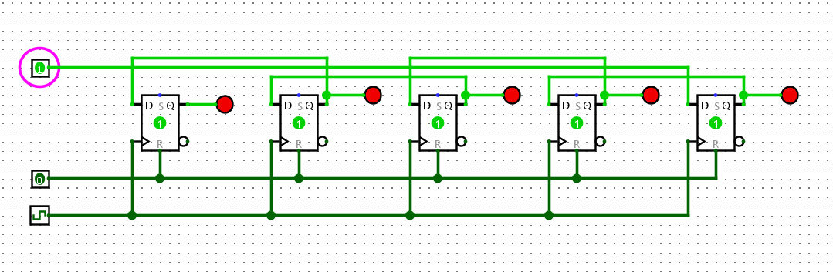
- For your shift register to work as a stack, it needs to be bi-directional. This means the input to any Flip Flop could come from two places - the left or the right. In lectures we discussed a simple “encoder” circuit that selects which of two data inputs is allowed through, based on a third selection bit. Design the logic for this 2-bit encoder, and demonstrate it to your lab demonstrator.
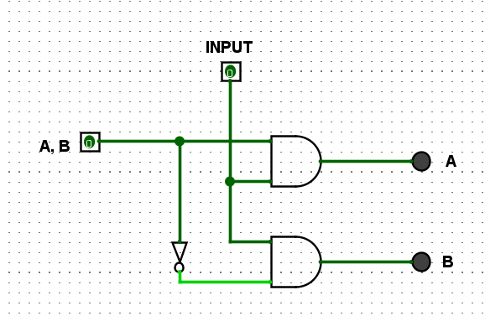

- Now incorporate your encoder above to allow bi-directional shifting of your stack. Your stack should:
  - push and pop bits onto and off the stack, using clock pulses and a direction toggle switch
  - show the state of each Flip Flop using LEDs.
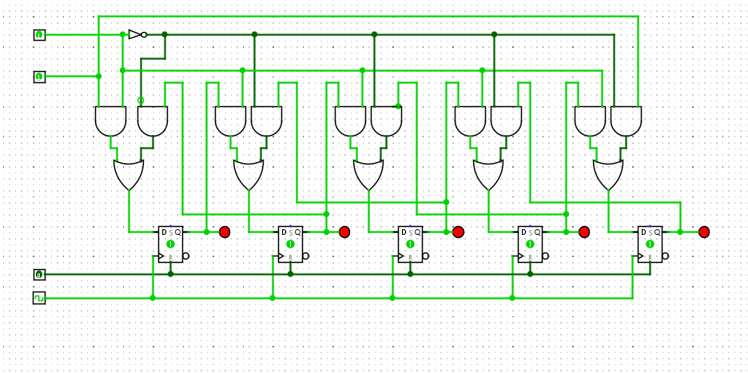
Export your circuit as an image and include it in your submission document. Demonstrate your working stack to your lab demonstrator.

- Modify your stack so that it has the option to read out its contents in parallel to a separate register of D Flip Flops. This should only occur when a “stack dump” toggle switch (i.e., pin) is enabled. When the toggle is disabled, the register of D Flip Flops should retain the last state read in (and should have LEDs connected to each Flip Flop out showing its state).
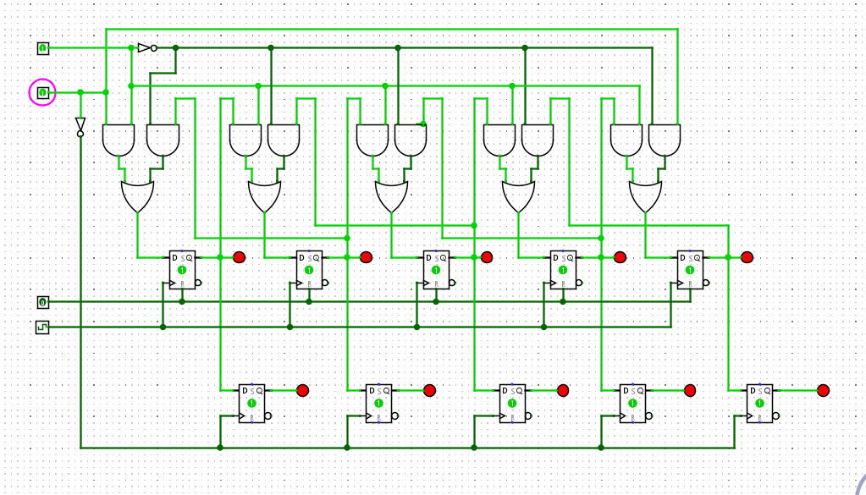
Export your circuit as an image and include it in your submission document. Demonstrate your working stack to your lab demonstrator.
When complete:
■ Submit your answers (screen shots, etc) in a single document using Canvas
■ Show your lab demonstrator your working circuits in class (you must do this to get the 1%). Your lab demonstrator may request you to resubmit if issues exist.

